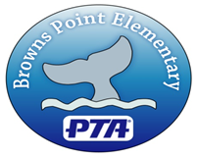
Browns Point Elementary PTA
Funding Request

Browns Point Elementary PTA receives numerous funding requests from parents, teachers, staff, and administrators throughout the school year. To make this process more efficient and to better document PTA activities, the PTA has created the Funding Request Form. Below are instructions and things to keep in mind when requesting PTA funds.
- All requests for PTA funds must be in writing using the attached form. Provide as much detail as possible and feel free to supplement the form with additional information.
- Requests may be by placed in the PTA mail box in the office.
- The PTA Board of Directors will review submitted requests at their next monthly meeting. You will be notified as soon as possible of the Board’s decision. The Board’s possible actions include approving the request, tabling the request for further information or denying the request. The Board may request that you attend a meeting to allow an opportunity for questions.
Things to keep in mind:
While all requests are worthwhile, the BPE PTA will only provide funding to those requests that are in line with its goals and missions and where resources are available.
PTA’s primary mission is to promote children’s well-being, and educational success through strong parent, family, and community involvement. There are a wide range of factors that go into supporting success. When providing your information, please let the Board know how your project does this. PTA places greater weight on projects that impact a large population of the school.
If funding is granted or denied, it does not mean that a precedent has been set or that any funds will be awarded or denied for similar future requests. PTA may be presented with a great project that can’t be funded during a specific semester or year, but could be funded at a different time. Equally, PTA may fund a project and then determine in the next year that a different request takes priority.
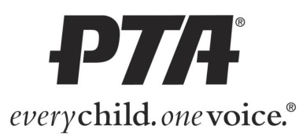
Browns Point Elementary PTA Funding Request Form

Person or Group making request: _________________________________________________________
Contact Number ______________________________ Email _________________________________
Description of item/project: ____________________________________________________________________________________
____________________________________________________________________________________
____________________________________________________________________________________
Detailed Cost Estimate:
____________________________________________________________________________________
____________________________________________________________________________________
____________________________________________________________________________________
____________________________________________________________________________________
Who will benefit from this item/project & how? ______________________________________________
____________________________________________________________________________________
____________________________________________________________________________________
____________________________________________________________________________________
____________________________________________________________________________________
Will volunteers be used/needed to implement project? Yes No
Date this item/project is needed: ____________________________________________
Date request submitted: ___________________________________________________
---------------------------------------------------------------------------------------------------------------------------------------- ----------
PTA Review date: ________________________________________________________
Comments/Questions: _________________________________________________________________
____________________________________________________________________________________
____________________________________________________________________________________
_________ Approved _________Denied _________ Additional information needed

